Ricardo Jacome

MECH 875 - Mechanical Vibrations

Professor: Dr. Joseph Turner

**Vibration Measurements on Steering Wheel Maneuvering**

**Abstract.**

The objective of this report is to offer a cost-effective solution for measuring steering wheel angles with noise due to vibrations in a vehicle. Traditionally, on car-crash testing there is not recordings of the steering wheel angles due to sensors getting damaged. A solution proposed to this problem is to use a wireless measurement device that broadcasts steering wheel data during vehicle testing. The resulting data is then filtered and analyzed to separate the noise measurements due to vibrations and the steering wheel data. From the results, the effectiveness of this method is evaluated, and future car-crash applications are discussed.

**Introduction.**

When measuring accelerations or angular rates in vehicles, vibrations from the road contribute noise to the measurements. During car-crash testing, the vibrations due to the impact become an obstruction to interpret data and often require heavy duty measurement devices. Furthermore, these devices need to be attached to a section that has the least damage to avoid malfunctions. For this reason, obtaining steering wheel angles becomes a task almost impossible during car-crash analysis. In this project, a disposable sensor is used to investigate the effectiveness on recording steering wheel angles during vehicle maneuvering. The outcome of the project would be to determine feasibility of this sensor in car-crash testing analysis.

The first section offers a Background Study on the subject. Secondly, an instrumentation section offers details of the specifications in the sensor along with the experimental setup. Third is the results and analysis that are found from the experiment. This analysis includes signal processing and response characterization of the system. Finally, a summary of conclusions and recommendations is offered for future research.

**Background.**

**Instrumentation and Testing Setup**

To measure the steering wheel angles, a Witmotion BWT61CL Sensor is used. This sensor contains a JY61 Gyroscope, a 150mAh lithium battery, and Bluetooth Transmitter. The sensor specifications are summarized on Table 1, and a sample image of the sensor is presented on Figure 1.

Table 1. Witmotion BWT61CL Sensor Specifications

|  |  |  |  |
| --- | --- | --- | --- |
| Parameter | Quantity | Parameter | Quantity |
| Voltage | 3.3 V – 5V | Current | < 40mA |
| Accelerated Speed Range | $±$ 16g’s | Angular Speed Range | $±$ 2000 $°$/s |
| Angle Range | $±$ 180 $°$ | Measurement Stability | 0.05 $°$/s |
| Output Frequency | 100 Hz | Baud Rate | 115200 pulse/s |
| Transmission Distance | <10 m | Date Interface | Serial TTL Level |

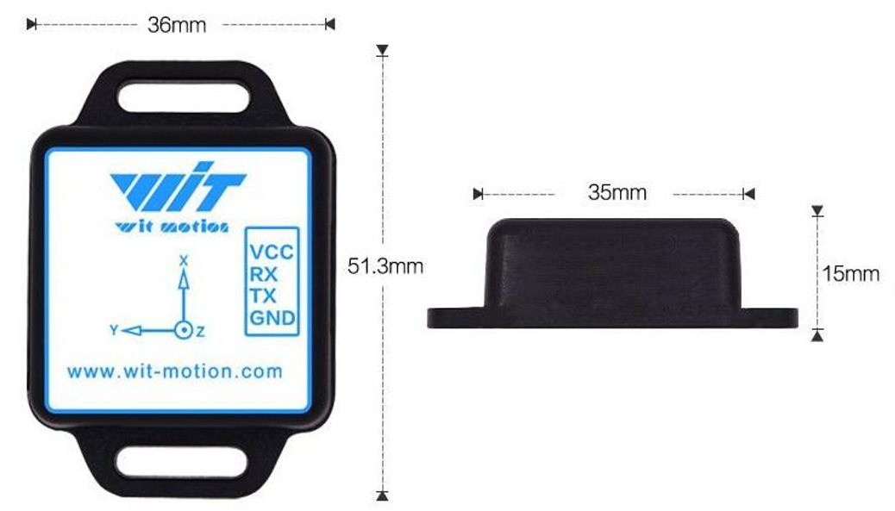

Figure 1 – Witmotion BWT61CL Sample Image with Dimensions

This sensor communicates with an Android device where the information is sent and stored. To perform this experiment, a Nissan Altima 2014 as shown in Figure 2, is used. The sensor is zeroed at the center of the steering wheel, and then attached with a 3D INSERT SOMETHING HERE as shown in Figure 2.

Figure 2 – Test Vehicle and Sensor Positioning in Steering Wheel.

The test took place in 2 different scenarios which consisted of a typical asphalt street and one with a rough terrain and uneven surfaces. Each scenario was repeated twice OR THRICE??? To verify consistency on results. The driving conditions consisted of first straight up driving followed by a right turning, driving straight up again and perform a left turn before stopping.

MAYBE ==== Test the Longest Range of Connectivity of the Sensor

**Results and Analysis**

The results provided from the experiment are summarized in Figure 3 and some main recordings are shown in Table 2.

**Conclusion**

From the results, it can be concluded….